Mphareng Madihlaba

Practical 2.1

1. Records where size is missing and the purchase amount is greater than 50.

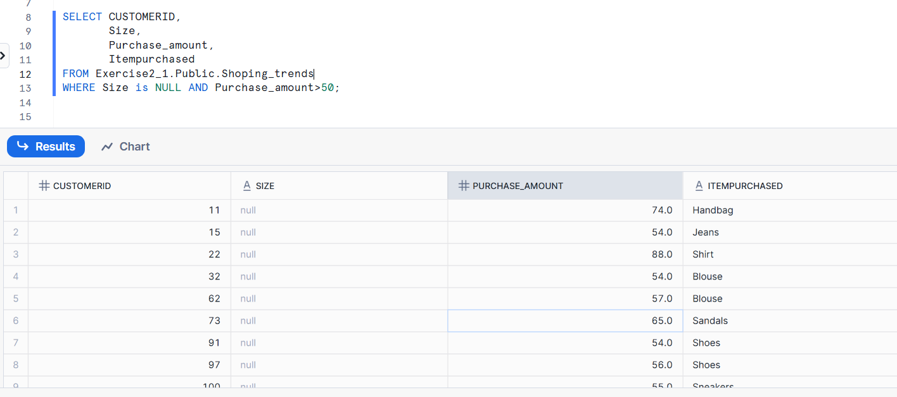

1. List the total number of purchases grouped by Season, treating NULL values as 'Unknown Season'.

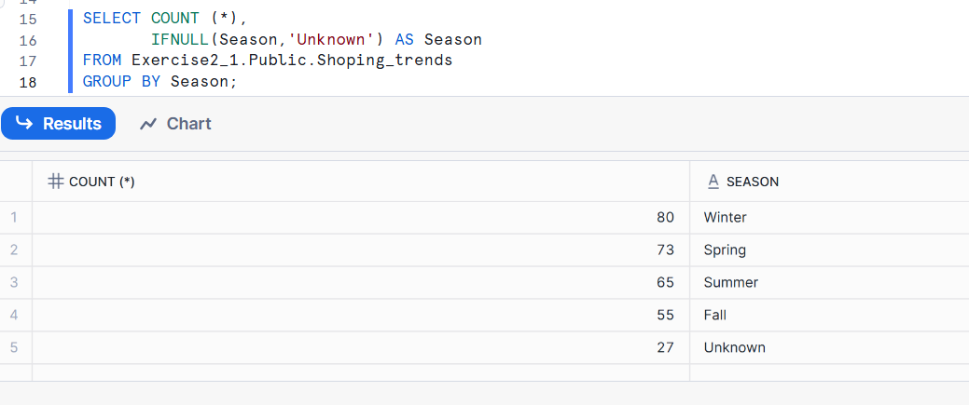

1. Count how many customers used each Payment Method, treating NULLs as 'Not Provided'.

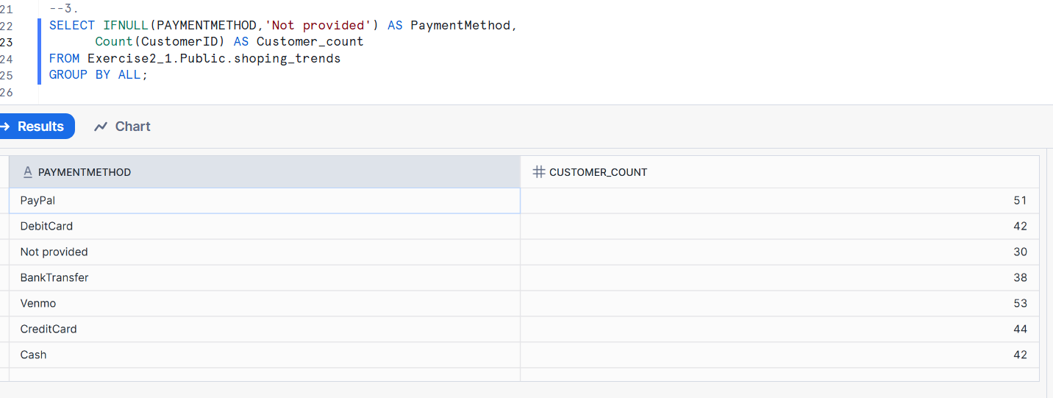

1. Show customers where Promo Code Used is NULL and Review Rating is below 3.0.

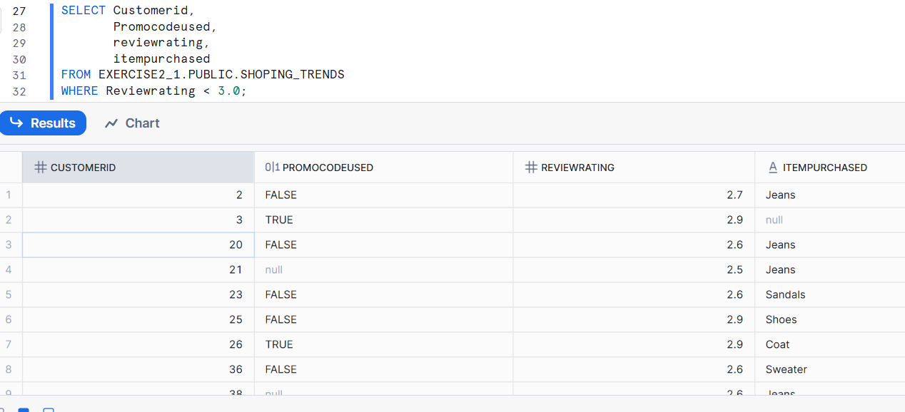

1. Group customers by Shipping Type, and return the average purchase_amount, treating missing values as 0.

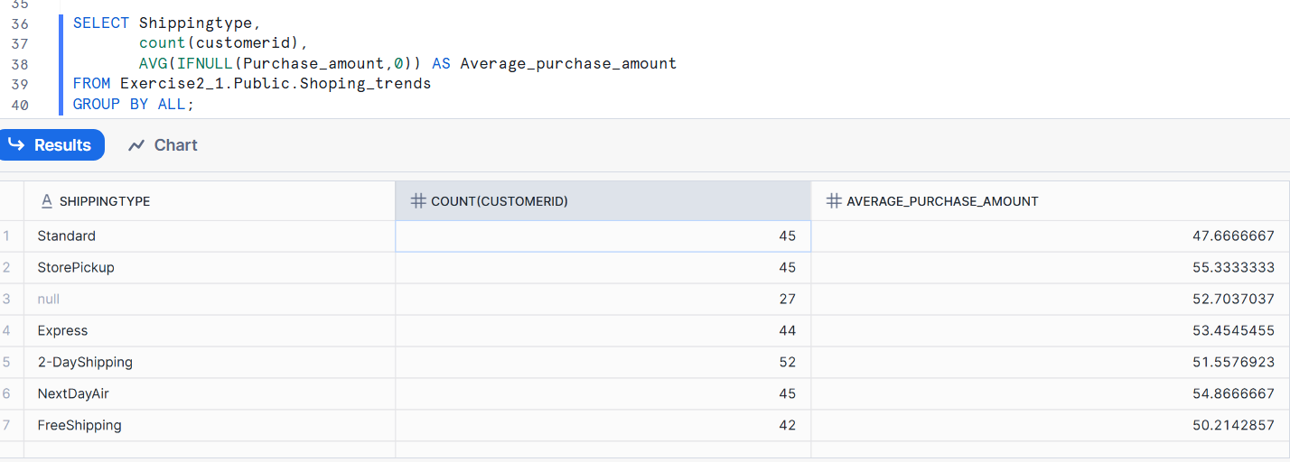

1. Display the number of purchases per Location only for those with more than 5 purchases and no NULL Payment Method.

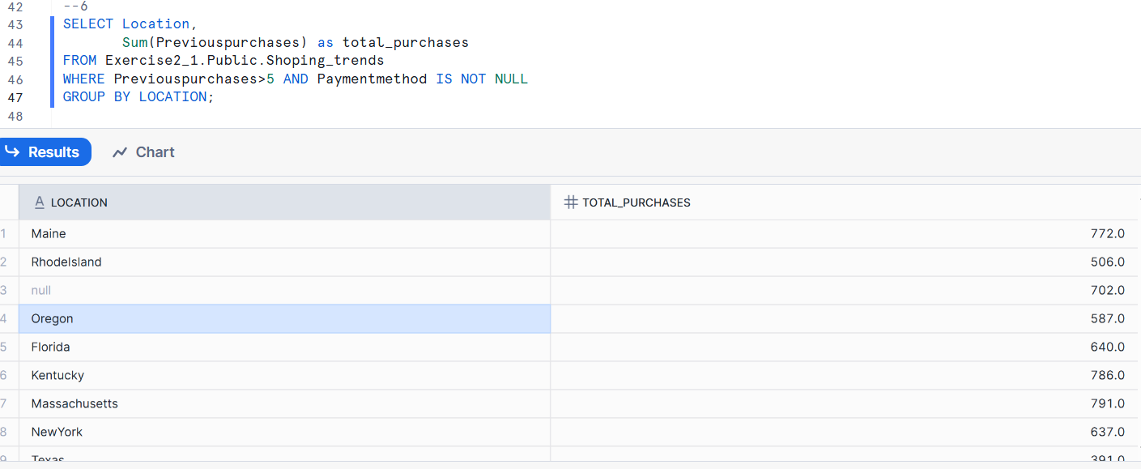

1. Create a column Spender Category that classifies customers using CASE: 'High' if amount > 80, 'Medium' if BETWEEN 50 AND 80, 'Low' otherwise. Replace NULLs in purchase_amount with 0.

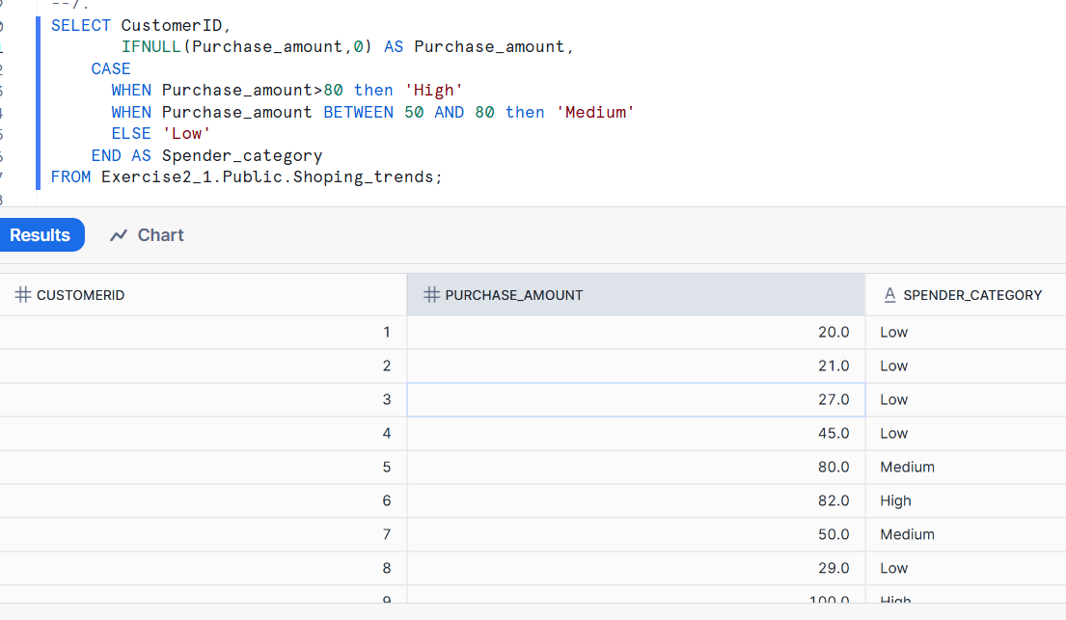

1. Find customers who have no Previous Purchases value but whose Color is not NULL.

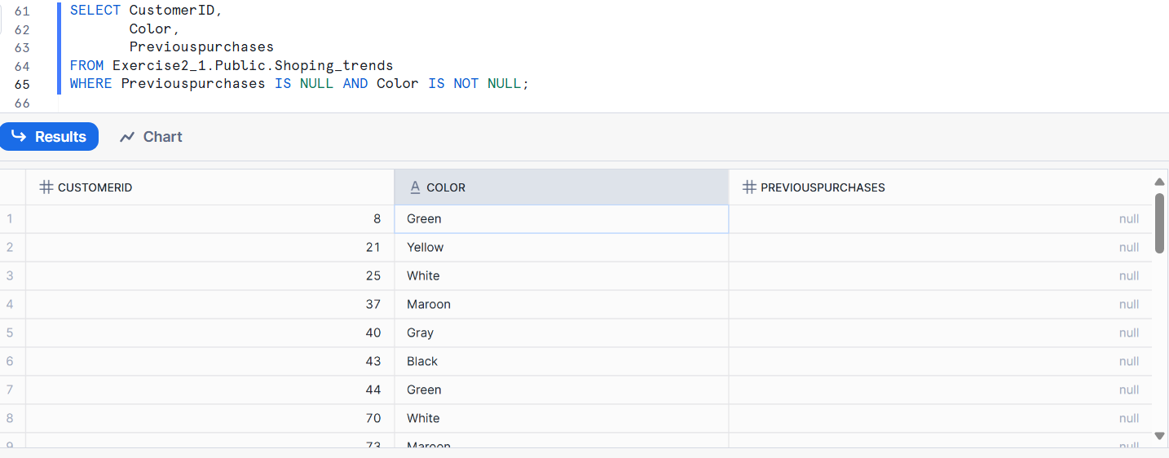

1. Group records by Frequency of Purchases and show the total amount spent per group, treating NULL frequencies as 'Unknown'.

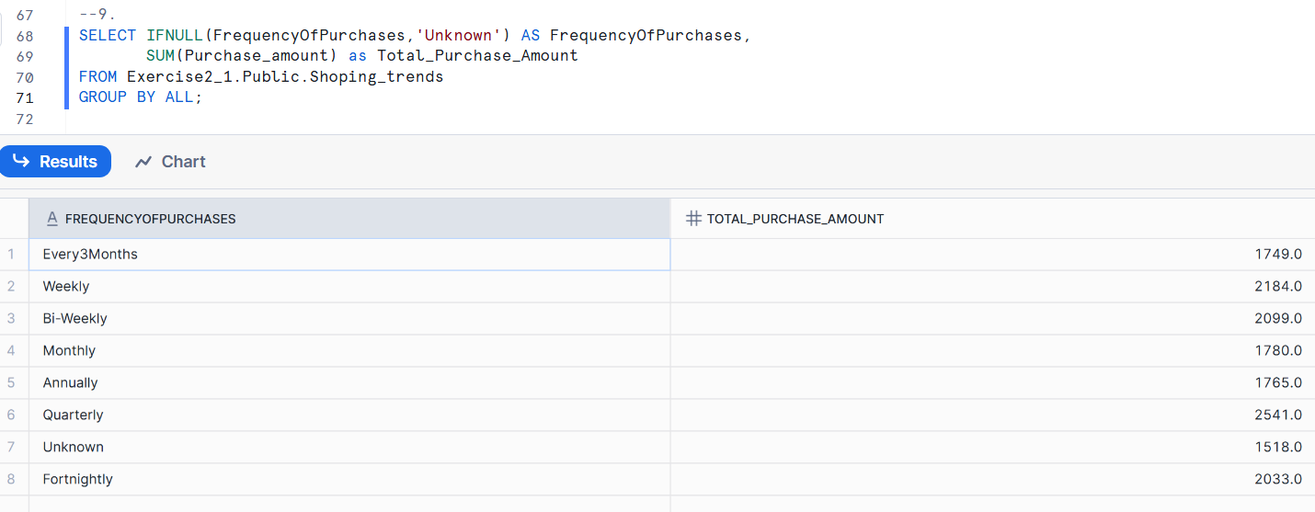

1. Display a list of all Category values with the number of times each was purchased, excluding rows where Categoryis NULL.

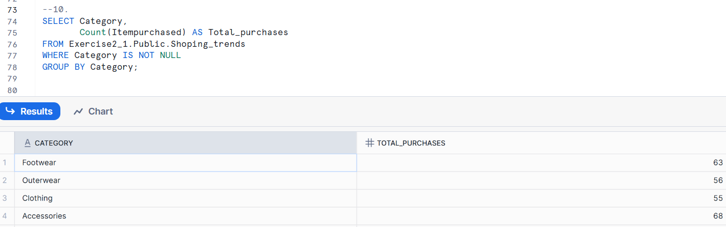

1. Return the top 5 Locations with the highest total purchase_amount, replacing NULLs in amount with 0.

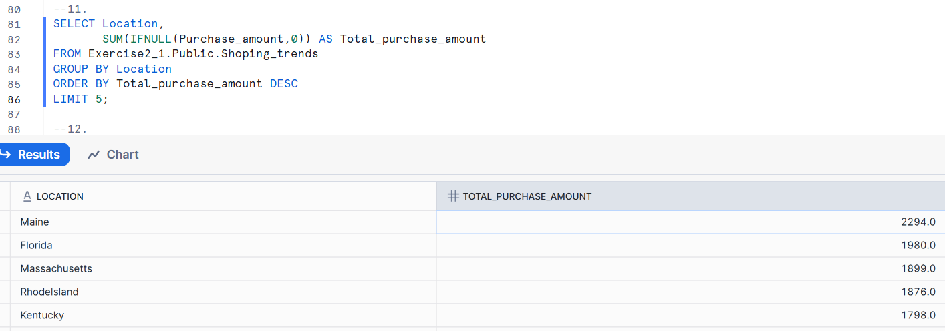

1. Group customers by Gender and Size, and count how many entries have a NULL Color.

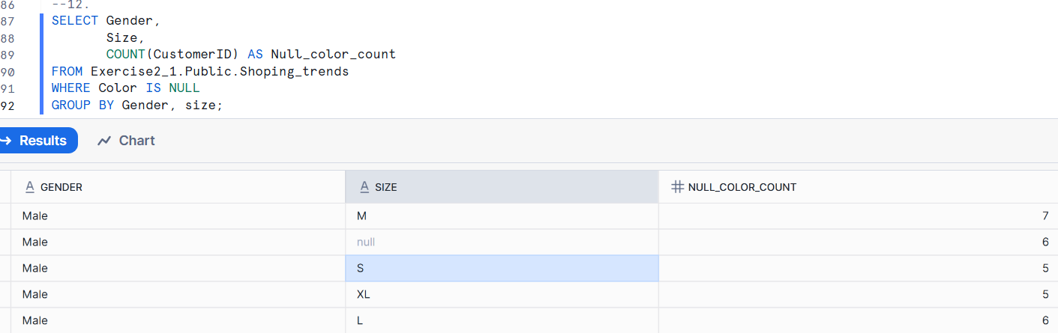

1. Identify all Item Purchased where more than 3 purchases had NULL Shipping Type.

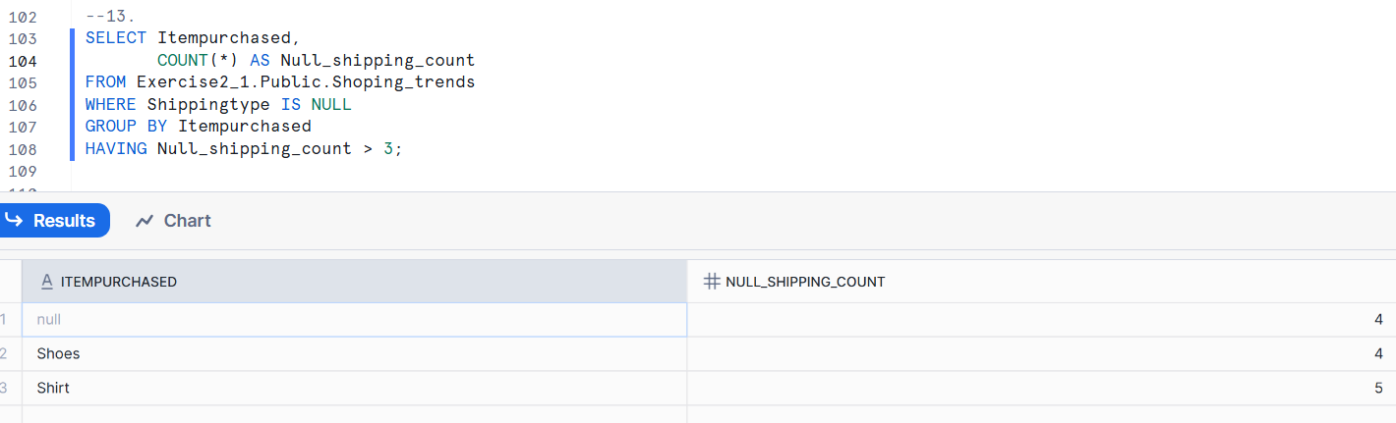

1. Show a count of how many customers per Payment Method have NULL Review Rating.

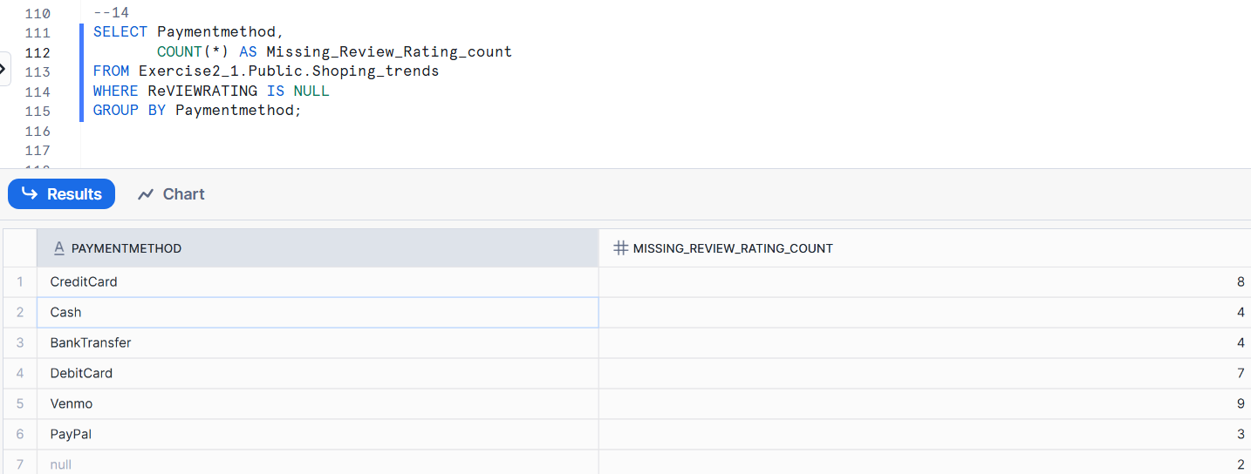

1. Group by Category and return the average Review Rating, replacing NULLs with 0, and filter only where average is greater than 3.5.

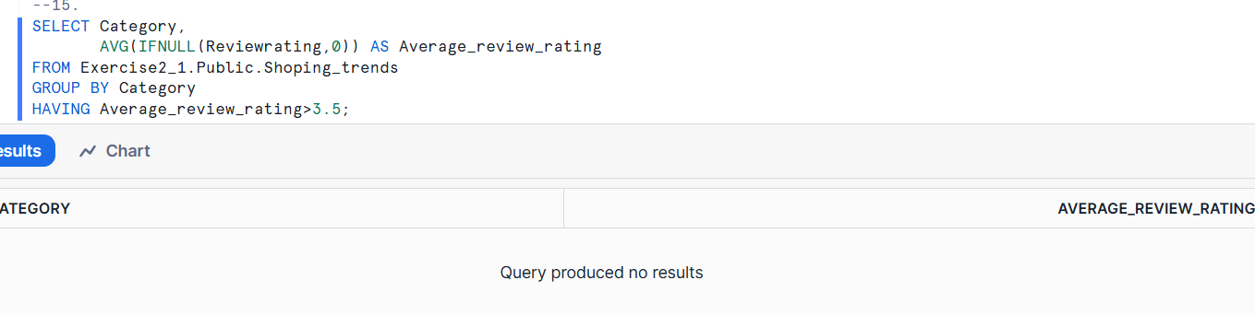

1. List all Colors that are missing (NULL) in at least 2 rows and the average Age of customers for those rows.

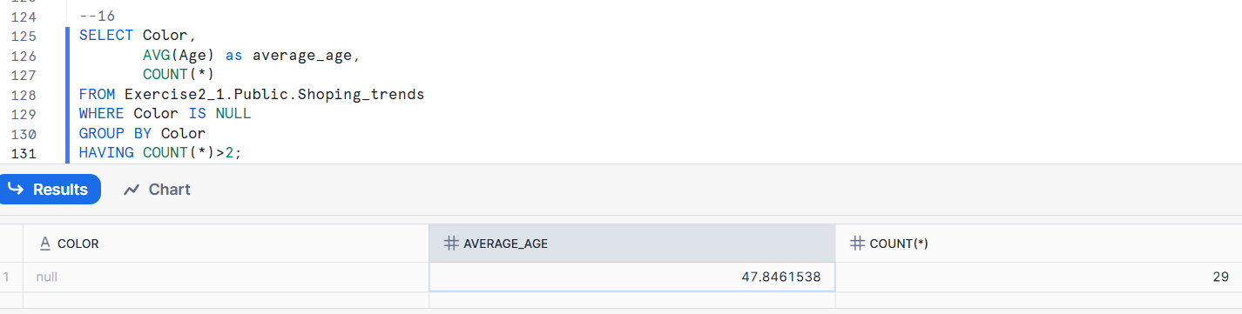

1. Use CASE to create a column Delivery Speed: 'Fast' if Shipping Type is 'Express' or 'Next Day Air', 'Slow' if 'Standard', 'Other' for all else including NULL. Then count how many customers fall intoeach category.

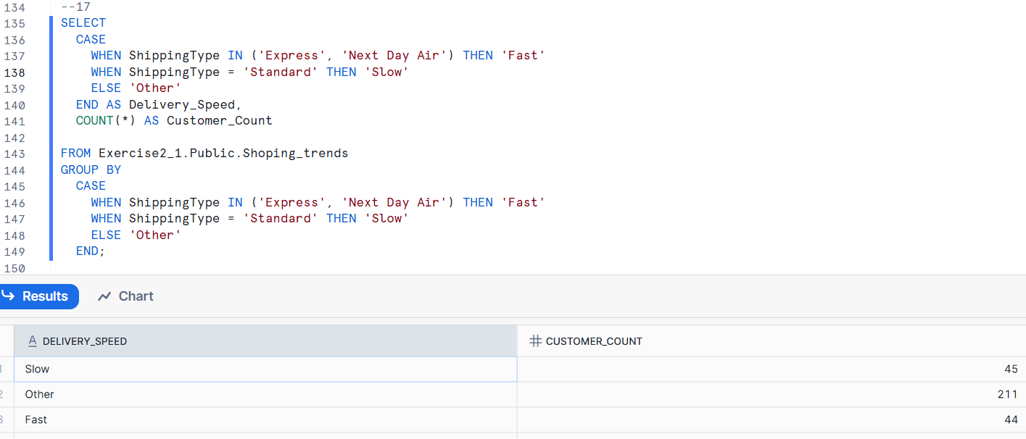

1. Find customers whose purchase_amount is NULL and whose Promo Code Used is 'Yes'.

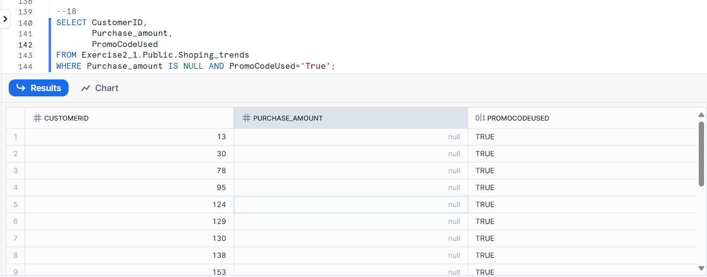

1. Group by Location and show the maximum Previous Purchases, replacing NULLs with 0, only where the average rating is above 4.0.

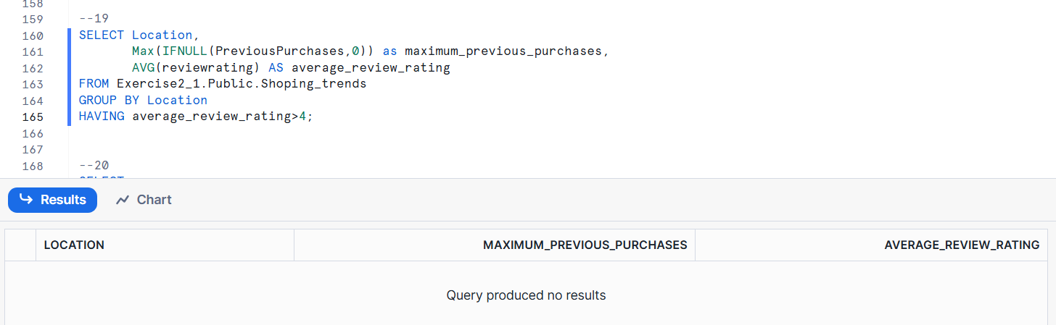

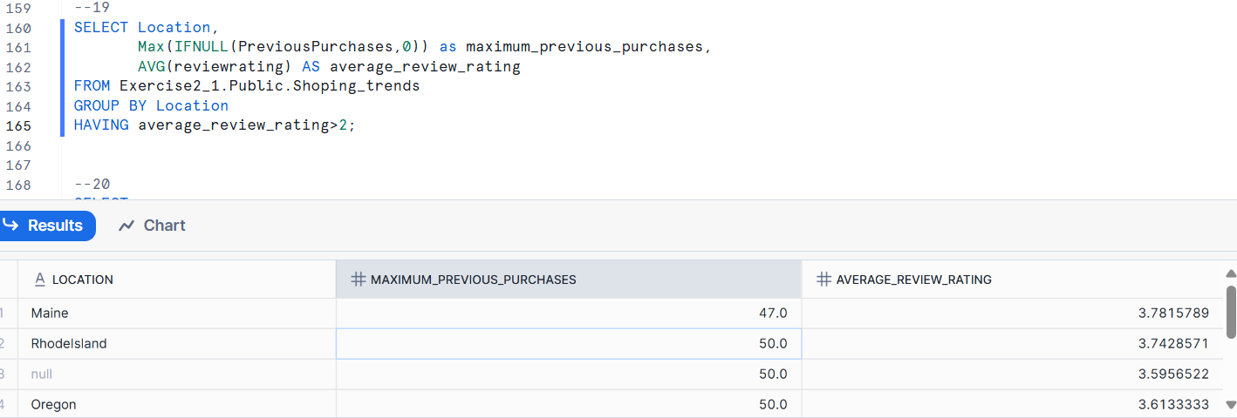

1. Show customers who have a NULL Shipping Type but made a purchase in the range of 30 to 70 USD.

